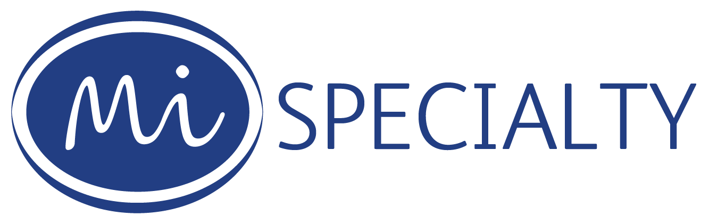

Broker information
Mi Specialty Ltd, Registered in England and Wales (No: 07313009).
Registered office: Affinity House, Bindon Road, Taunton, Somerset TA2 6AA.
Mi Specialty Ltd is authorised and regulated by the Financial Conduct Authority FRN: 969896.
Mi Specialty Ltd is part of the Lloyd & Whyte Group.

Our relationship with you
We are an independent Managing General Agent operating predominantly with binding underwriting authority from our insurers. We do not provide advice on any of our products.
Your Clients will remain yours throughout our arrangement. You have agreed to place the interests of your clients before all other considerations and are responsible for establishing whether the product meets your clients Demands and Needs and providing the appropriate Summary of Cover prior to completion of a contract of insurance.

Whose Products do we offer?
We offer insurance products tailored for our market, underwritten by a number of insurers in the open market and by certain underwriters at Lloyd’s. These are set out in the specific policy documents. For the purposes of Product Governance, both we and the Insurers are considered to be joint product manufacturers. You, the broker, is classified as a distributor.

How are we remunerated?
We receive commission for each policy from the insurer, and we may in addition, receive a profit share from the Insurer. We charge an individual policy fee on all new business and renewal. If you would like further details of the commission arrangement on this policy please contact us.

